**Project 2 Proposal**

**Client and Topic**

I will be creating a portfolio website for my photography hobby. I intend for this website to be a catalogue of all of the places I’ve been, and the pictures that I’ve taken at those places.

**Development Process and Engagement**

The website will be a display website that I will send as a portfolio to people of interest (employers, friends and family, etc). Since there is no specific client, I will be creating my own theme for the website and expressing my personality through how it looks. While I intend to create a theme specific to me, I want to ensure that the content is easy to read on the website.

**Testing**

As far as testing the code to ensure it is working properly, I have several tools on my computer to view the website live while I am making changes. Additionally, I will use the HTML and CSS validators that you have instructed us to use for testing to ensure that there are no issues that are undetected by Visual Studio Code, which is what I use for my web projects. Finally, I use Vercel to publish my website, so that I can test it on various devices.

**Description**

My “business” is just advertising myself as a freelance photographer. The overall goal of this website is to showcase my photography skills so that I can potentially be hired or contracted by companies, event organizers, and families looking for a photographer. My target audience is individuals looking for a freelance photographer or a photographer to hire, with age and cultural background being irrelevant. Additionally, I do want to share my camera settings and the gear that I use with other photographers, so I will include information such as ISO, f-stop/aperture, shutter speed, etc. However, this information will be in the captions and minimally invasive to the rest of the content. This will allow other photographers to give feedback on my photos and the settings and tools that I use, while not deterring non-photographers from interacting with the website.

**Growth and Maintenance**

My website will grow with each installment I make to the catalogue. The best thing that I can do to make my website easier to maintain is to create a system to optimize existing code and reuse code whenever possible. The layout of each gallery will be relatively the same, so I will need to create a system that allows me to easily create each photo gallery. With each photo gallery I include, I will need to make sure that the other existing galleries aren’t affected, and that the new content doesn’t disrupt the website in any other way. Other than that, I believe that my website will not need maintenance outside of monthly checkups.

**Organization**

To start, each page in the website will have a navigation bar at the top, which will allow the users to access the four main pages: the home page, the photo galleries page, the page to request info, and the page with my contact information. Each photo gallery can be considered a “sub topic”, but each gallery will have their own page, accessible by the main photo galleries page. For my ten pages, four of them will be the four pages I discussed, as well as six photo galleries from the photos I have on my computer. Each gallery will have a description that will give context and explain where the photos were taken, if they were for a specific event, and the time range that they were taken in.

Here are two example wireframes: one for my home page, and one for my information request page:

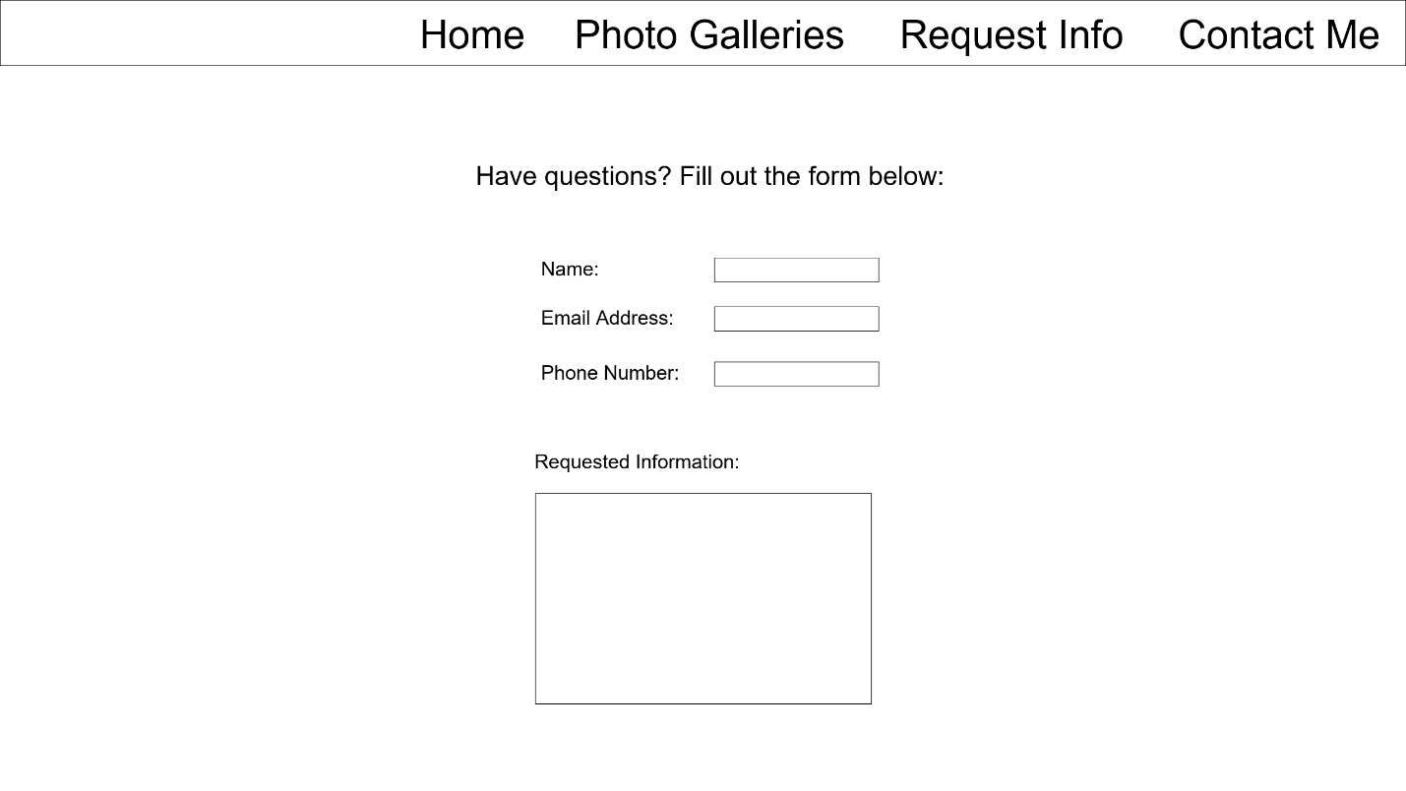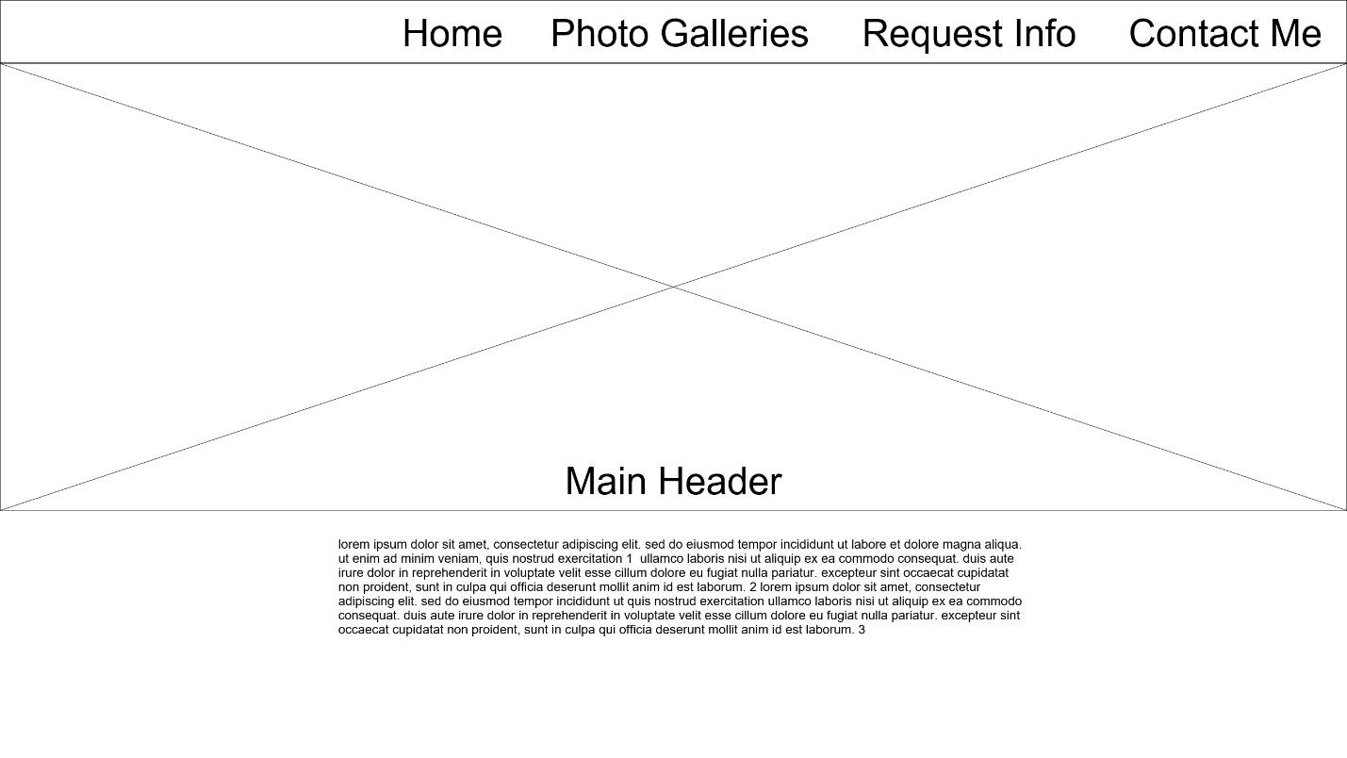

**Security**

This website is simply a display website, so no accounts will be created, and there will be no e-commerce components as of right now. However, I do intend to have a page with my relevant contact information, pricing, and a form for any questions that the users might have. The only security I will need to implement is a system to prevent people from accessing data from the forms that are submitted.

**Web Hosting**

When selecting a web host, I want to find something more affordable rather than a high-performance host. My website is not going to be very intensive, so I am looking for something affordable. Additionally, I want my website host to have security features built into it, since I have not implemented any type of website security before. Outside of HTML, CSS and JavaScript, my website will not need to support any other languages. Since I do not plan to add any advanced features to this website, I shouldn’t need to use anything outside of those three languages. While I plan to also use LESS scripts, which I will compile on the client side to avoid any browser compatibility issues. I have chosen to use the name “jlphotography.com” as my website domain, because it has my initials in it, and the domain name is relevant to the content on the website.

**Marketing**

I do not plan to pay for any marketing, and all advertisement for the website will be done by me. For search engine optimization, I plan to use the proper semantic tags within my page to ensure crawlability, as well as add relevant keywords such as photography, photographer, freelancer etc. to my meta tag so that if users are searching for photographers, my website shows up on the list.